**Collecting and Representing Data**

During the past few lessons you have looked at ways of collecting and representing data. You will now put all of your knowledge together to complete these questions.

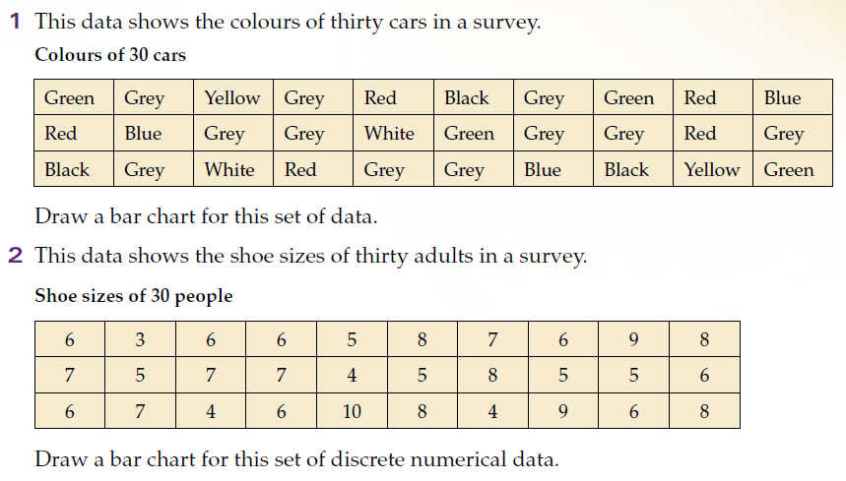**Question 1:** The information shown displays the colour of 30 cars in the school car park. Complete the tally chart below.

|  |  |  |
| --- | --- | --- |
| **Car Colour** | **Tally** | **Frequency (Total)** |
| Green |  |  |
| Grey |  |  |
| Yellow |  |  |
| Red |  |  |
| Black |  |  |
| Blue |  |  |
| White |  |  |

**Question 2:** Using your Frequency table answer these questions.

a) How many cars on the car park are Grey?

b) How many more Red cars than White cars are there?

c) Which is the most popular colour?

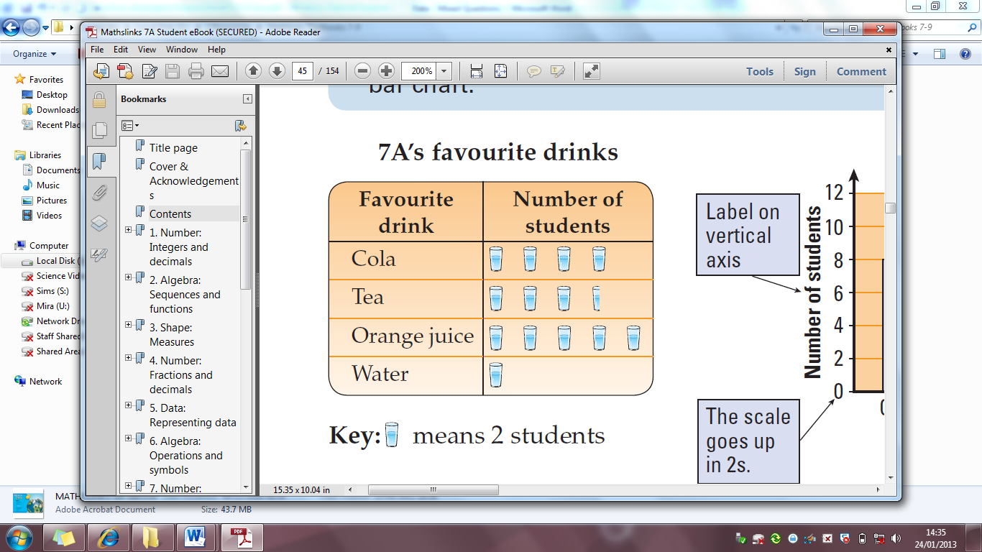

**Question 3:** Using the Pictogram on the right answer the following questions.

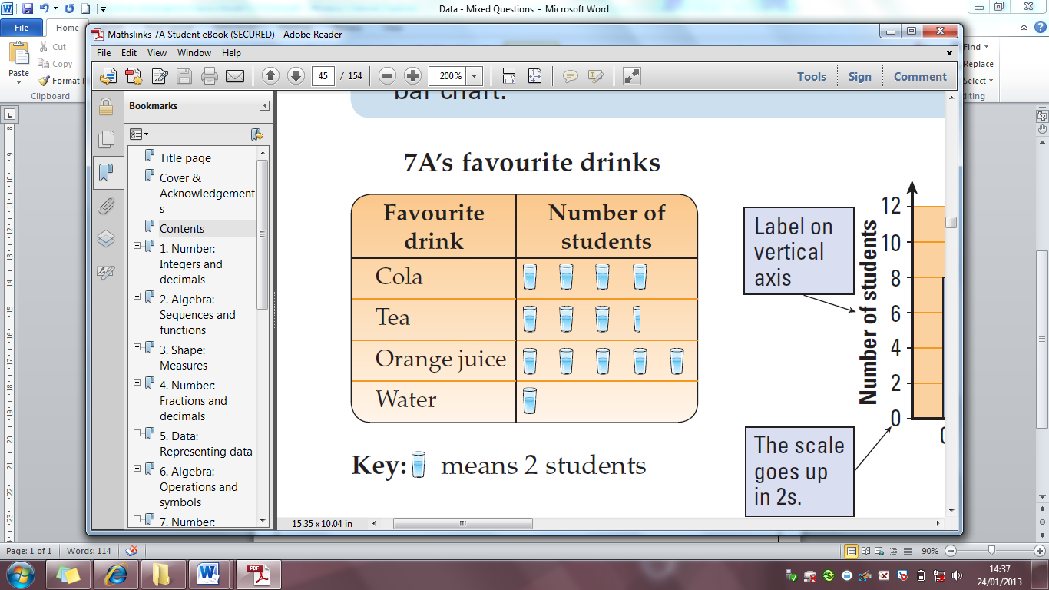

When stands for 2 students:-

a) How many students liked Cola?

b) How many students liked Tea?

c) How many more students liked Orange Juice than water?



If stood for 1 student, explain why this could not be possible.

……………………………………………………………………………………………………………………………………………………………………………………………………………

……………………………………………………………………………………………………………………………………………………………………………………………………………

C:\Program Files\Microsoft Office\MEDIA\CAGCAT10\j0299763.wmf**Question 4:** The number of goals scored by a footballer this season can be represented by a . Using the information below draw a Pictogram to represent the information .

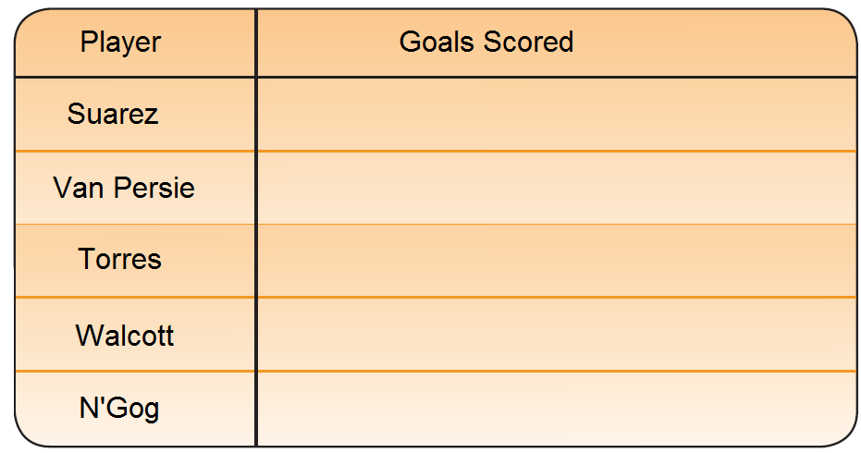

Suarez = 16

Van Persie = 18

Torres = 5

Walcott = 10

N’Gog = 3

Key:  = 2 goals

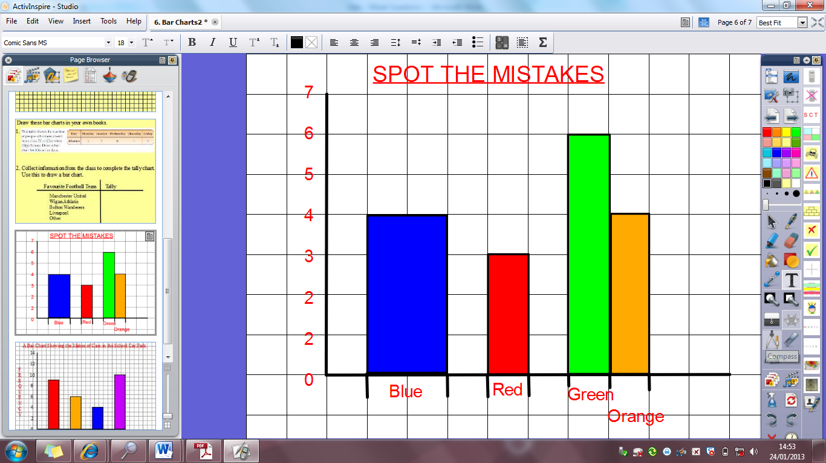**Question 5:** Write down as many things as you can that are wrong with this bar chart.

1. ……………………………………………………………………………………………………

2. ……………………………………………………………………………………………………

3. ……………………………………………………………………………………………………

4. ……………………………………………………………………………………………………

5. ……………………………………………………………………………………………………

6. ……………………………………………………………………………………………………

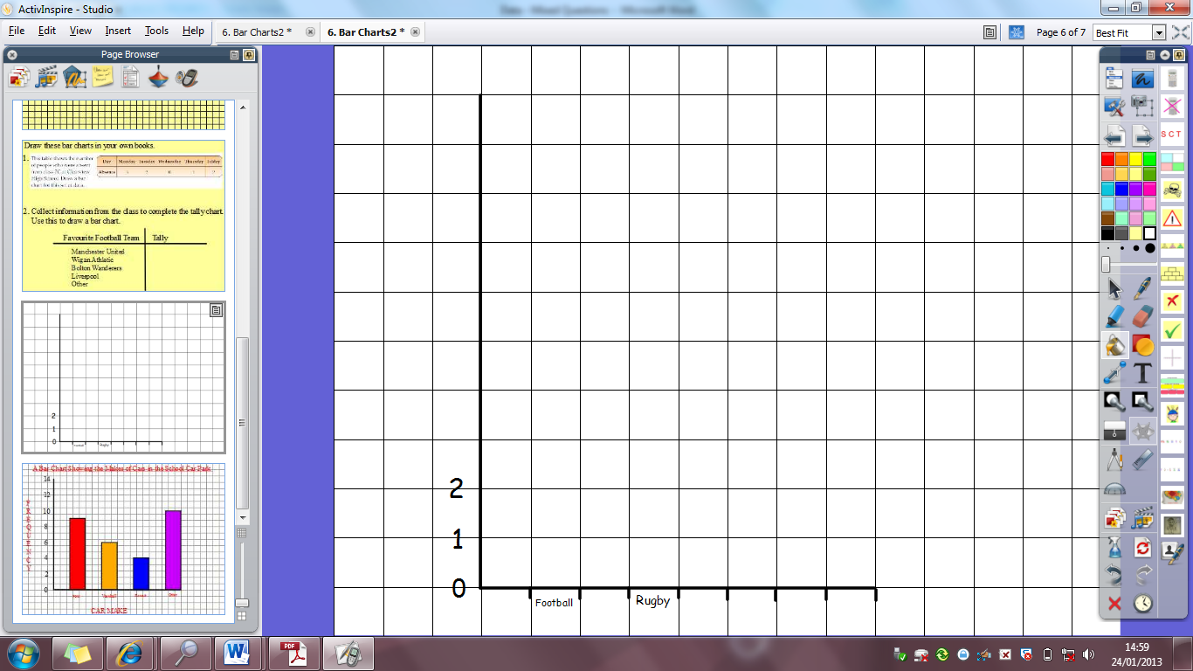**Question 6:** The pictogram below shows the favourite sports of pupils from a Year 7 class. Draw a bar chart showing this information.

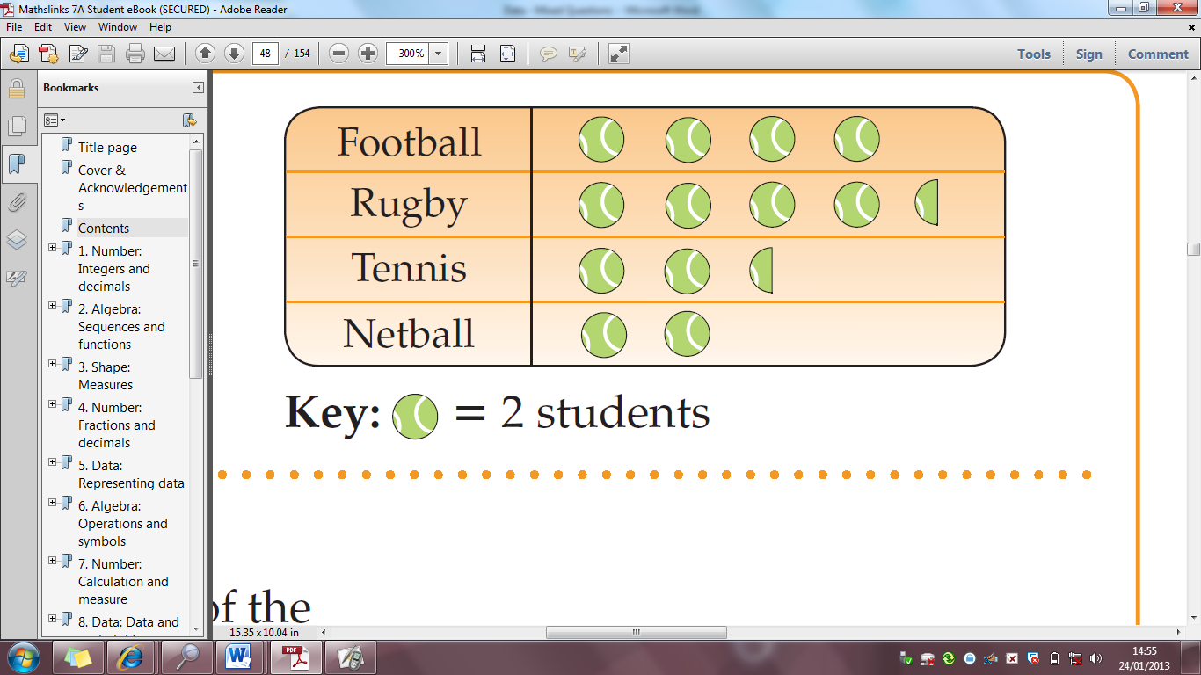

Checklist:

1. Frequency going up in equal amounts

2. Bars are the same width

3. Same sized gaps between the bars

4. All lines draw with a ruler

5. Both the x and y axis have labels

6. The bar chart needs a title

**Question 7:** Draw a stem and leaf diagram for the following set of data. 35, 37, 52, 51, 58, 47, 45, 36, 37

|  |  |
| --- | --- |
| Stem | Leaf |
| 3 |  |
| 4 |  |
| 5 |  |

|  |  |
| --- | --- |
| Stem | Leaf |
| 3 |  |
| 4 |  |
| 5 |  |

|  |  |  |  |  |
| --- | --- | --- | --- | --- |
|  | ***Statement*** | **Not**  **Met** | **Part**  **Met** | **Fully**  **Met** |
| ***1*** | **I can use tally charts/frequency tables to answer questions** |  |  |  |
| ***2*** | **I can draw and use bar charts** |  |  |  |
| ***3*** | **I can read information from Pictograms; and draw them.** |  |  |  |